PROPOSAL

THIRD PARTY MONITORING OF MECHANIZED HOUSEKEEPING SERVICE PROVIDER
GUJARAT STATE ROAD TRANSPORT CORPORATION

GOVERNMENT OF GUJARAT

QUALITY COUNCIL OF INDIA
World Trade Centre, J 200, Block J,
Nauroji Nagar, New Delhi-110029
T: +91-11 - 26186680; F: +91-11 – 26186683
W: www.qcin.org E: info@qcin.org

Contents
About QCI 3
QCI: Past Few Years 4
Objective 5
Approach 5
Execution Methodology 6
Outputs Expected 7
General Terms and Conditions 7
Financials 8

About QCI
- QCI has been set up as a non-profit autonomous society registered under the Societies Registration Act XXI of 1860 to establish an accreditation structure in the country and to spread quality movement in India by undertaking a National Quality Campaign.
- QCI was established as an autonomous non-profit organization by the Government of India and the Indian Industry represented by the three major industry associations: ASSOCHAM, CLL, and FICCI. The Department for Promotion of Industry and Internal Trade (DPIIT), Ministry of Commerce and Industry is the nodal point for all matters connected to quality and QCI.
- The Council was established to create a mechanism for third-party assessment of products, services, and processes. In tune with the international best practices, it was envisaged that the Council would ensure that the quality of life of citizens is improved. It was therefore befitting that the Council was organized as an Independent Professional body with representation from the government and the industry, and with its own rules, powers, and functions strictly as per the MoA of the Society.
- The National Accreditation Board for Certification Bodies (NABCB), a constituent Board of QCI, is the apex national accreditation body that provides accreditation to Certification as well as Assessment Bodies by ISO Standards, international requirements/guidelines, and NABCB Accreditation Criteria.
- NABCB is internationally recognized and represents the interests of the Indian industry at international cooperation frameworks such as the International Accreditation Forum (IAF), International Laboratory Accreditation Cooperation (ILAC), and its recognized regional bodies such as the Asia Pacific Accreditation Cooperation (APAC). Its objective is to promote acceptance of India’s certifications and inspections internationally by becoming a signatory to the Multilateral/Mutual Recognition Arrangements (MLAs/MRAs) of these bodies after undergoing successful international peer evaluations.
- The National Accreditation Board for Testing and Calibration Laboratories (NABL) is another constituent board of QCI that accredits laboratories across scopes. NABL has been a Mutual Recognition Arrangement (MRA) signatory member of APAC (Asia Pacific Accreditation Cooperation) and ILAC (International Laboratory Accreditation Cooperation) since 2000. NABL in the year 2016 achieved the APAC MRA signatory status for Proficiency Testing Providers (PTP) and Reference Material Producers (RMP) schemes along with the extension in the existing fields of Testing, Calibration, and Medical. In October 2019, NABL also obtained ILAC MRA for Proficiency Testing Providers (PTP) accreditation program (ISO/IEC 17043) in addition to existing Testing including Medical (ISO/IEC 17025 and ISO 15189) and Calibration (ISO/IEC 17025) programs.
The organization structure of Quality Council of India is depicted below:
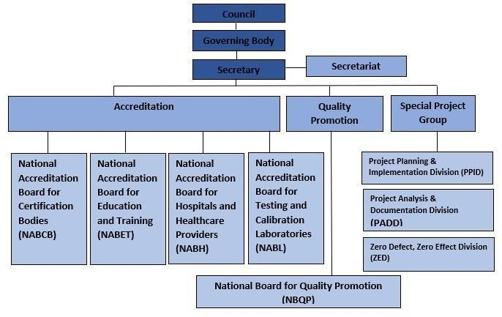

QCI: Past Few Years

QCI supporting government initiatives across Sectors | Quality at various stages of life
- Coal India Limited and State-owned mines – to sample and grade 100 MMT+ of coal annually
- ONDC – to revolutionize & democratize the e commerce ecosystem in India
- Swachh Bharat Mission – to fulfil vision of Clean India
- Zero Defect Zero Effect - Enhancing MSME Competitiveness
- Ayushman Bharat – for improving quality of empanelled health institutions
- Food Corporation of India (FCI): transform procurement & storage of food grains through assessment of warehouses & technology infusion
- Namami Gange Mission – for rejuvenating water bodies in Ganga basin
- Jal Jeevan Mission – to provide potable water to every family
- DARPG – for effective grievance redressal with a citizen centric approach



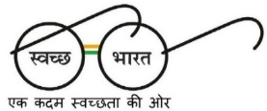
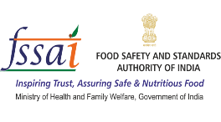


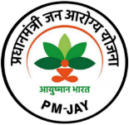
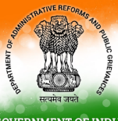

Monitoring
Assessment
Project Management
Strategy
Public Procurement
Hygiene & Sanitation
Food Quality
Tourism
Tourism
Natural Resources
Health Care
Admin Reforms
Railways

Objective
The objective of the proposed engagement is to establish a structured, independent, and periodic monitoring mechanism for bus depots under the jurisdiction of the Department.
Quality Council of India (QCI) will support the Department through systematic physical inspections at depot level, enabling objective assessment of operational practices, service conditions, and compliance with prescribed standards. The engagement is designed to ensure consistent oversight, generation of evidence-based insights, and informed decision-making through periodic monitoring. The monitoring outputs generated through this engagement will be captured in a structured manner and integrated with the Department’s existing information system, facilitating consolidated review, comparative analysis, and long-term tracking of depot-wise performance.

Approach
2.1 Monitoring Framework and Planning
- Development of a standardised monitoring and assessment framework applicable across all identified bus depots
- Finalisation of assessment parameters, inspection protocols, and documentation formats in consultation with the Department
- Preparation of a structured inspection plan to ensure periodic coverage of all depots within defined monitoring cycles
2.2 Depot-Level Inspections
- Surprise on-site inspections of bus depots through trained and independent monitoring personnel
- Uniform application of the approved assessment methodology and inspection protocols across all locations
- Recording of inspection observations supported by appropriate documentary and visual evidence, in line with prescribed guidelines
- Physical inspection of buses on a sample basis, along with collection of citizen feedback, as per the approved methodology, to validate service quality and on-ground conditions
2.3 System-Based Reporting and Data Integration
- Compilation of inspection findings in a structured digital format aligned with the Department’s existing information system
- Timely uploading and integration of inspection data and supporting records, as per agreed protocol
- Maintenance of data accuracy, completeness, and consistency for effective departmental review and analysis

2.4 Quality Assurance and Oversight
- Establishment of an internal quality assurance mechanism to oversee field inspections and validate findings
- Internal verification and random checks to ensure reliability and consistency of inspection outcomes
2.5 Reporting and Review Support
- Preparation of depot-wise and consolidated reports based on inspection outcomes
- Highlighting of critical observations, recurring gaps, and areas requiring immediate attention
- Support for review meetings, discussions, and presentations as required by the Department
- Development and deployment of a comprehensive performance dashboard (valid for 6 months), showcasing weekly inspection reports, key performance metrics, and trend-based analysis for depot-wise and consolidated monitoring

Execution Methodology
The assignment will be executed over a period of three (3) months, with a structured and time-bound monitoring plan to ensure each depot is inspected once every 7 days. The execution methodology is designed to enable systematic coverage of all 155 depots through phased inspections, supported by preparatory activities, standardisation of tools, and quality assurance mechanisms to ensure consistency and reliability of monitoring outcomes.
S. No. | Particular | Timeline
1 | Inception meeting with the Department, finalisation of monitoring framework, training and orientation of assessors | T+2 Weeks
2 | Phase 1: Inspection Cycle | T+3 Weeks
3 | Phase 2: Inspection Cycle | T+4 Weeks
4 | Phase 3: Inspection Cycle | T+5 Weeks
5 | Phase 4: Inspection Cycle | T+6 Weeks
6 | Phase 5: Inspection Cycle | T+7 Weeks
7 | Phase 6: Inspection Cycle | T+8 Weeks
8 | Phase 7: Inspection Cycle | T+9 Weeks
9 | Phase 8: Inspection Cycle | T+10 Weeks
10 | Phase 9: Inspection Cycle | T+11 Weeks
11 | Phase 10: Inspection Cycle | T+12 Weeks
12 | Final submission of Depot-wise and Consolidated Report | T+12 Weeks

Outputs Expected
3.1 Inspection and Reporting Deliverables
- Consolidated depot-wise inspection report covering all monitoring cycles, to be submitted at the end of the assignment
- Supporting evidence and documentation corresponding to inspection findings
- Consolidated performance summaries highlighting key observations and trends
3.2 System-Integrated Records
- Digitally captured inspection data integrated with the Department’s existing information system
- Updated records enabling comparative analysis across depots and monitoring cycles
3.3 Decision-Support Outputs
- Management-level summaries highlighting key findings, risks, and priority areas
- Analytical inputs to support follow-up actions, corrective measures, and policy-level review

General Terms and Conditions
- AMENDMENT OF THE AGREEMENT: No amendment or modification of this agreement shall be valid unless it is made in writing jointly by both parties or by their authorized representatives and specially stating the reason for amendment to this agreement. The modification/changes shall be effective from the date of which they are made/executed unless otherwise agreed to.
- FORCE MAJEURE: The parties shall ensure due compliance with the terms of this agreement. However, no party shall be liable for any claim for any loss or damage whatsoever arising out of failure to carry out the terms of the agreement to the extent such a failure is due to force majeure events such as fire, rebellion, mutiny, civil commotion, riots, strike, lockout, force of nature, accident, act of God, or any other reason beyond the control of concerned party.
- ARBITRATION: The disputes, if arising, shall be settled by arbitration in accordance with the procedure prescribed in Arbitration and Conciliation Act of India, 1966 or any statutory modification or re- enactment thereof and the rules made thereunder and for the time being in force. Proceedings shall, unless otherwise agreed by the parties, to be held in Delhi, India.
- NOTICE: All notices permitted or required to be given under the provisions of this agreement shall be deemed to be sufficiently given if written and delivered personally or sent to the other party by telefax or certified or registered air mail or email and addressed to the registered office of the other party as follows or to such other party address as the party may give notice in writing. Unless otherwise provided herein all such notices shall be deemed to have been given as of the date they are personally delivered or transmitted by telefax or email or deposited in the mail.

Financials

S. No. | Particulars | Period | Amount
1 | Field Assessment
2 | Headquarter Support Team
3 | Data Collection Tool
4 | Report
5 | Admin @12%
Total

The Above Financial quote is exclusive of GST*

